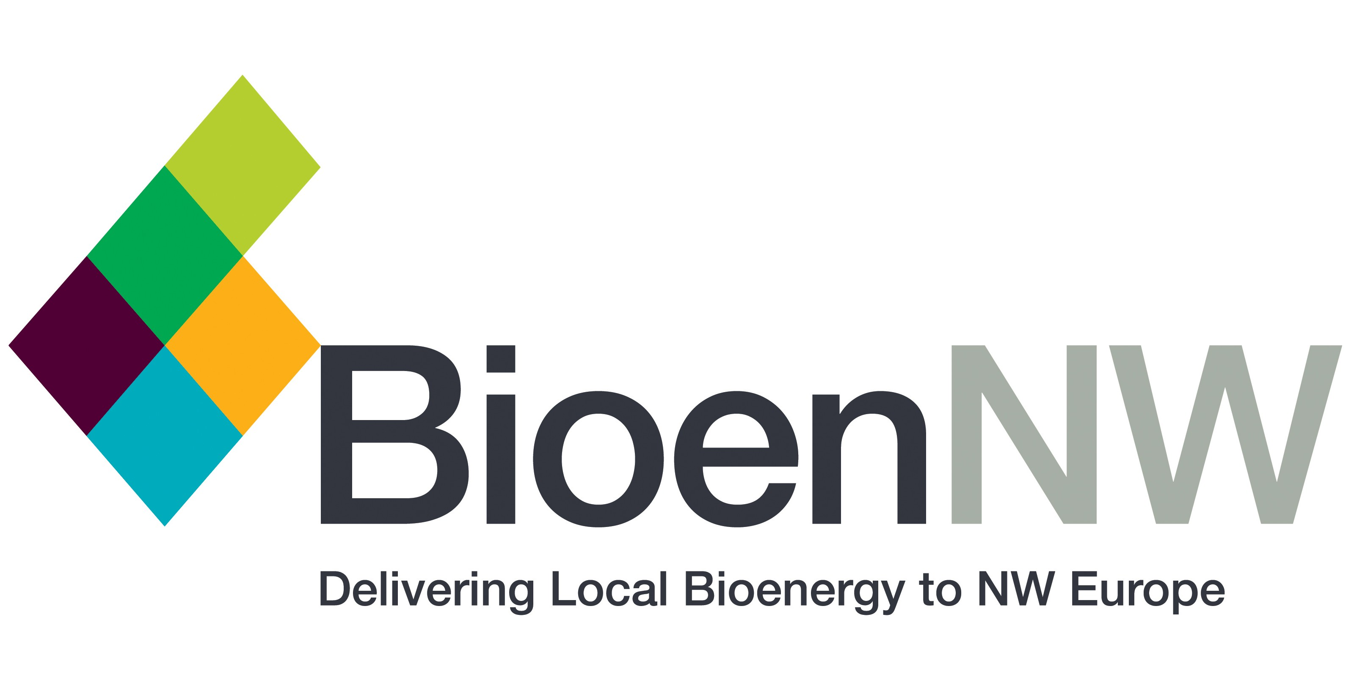
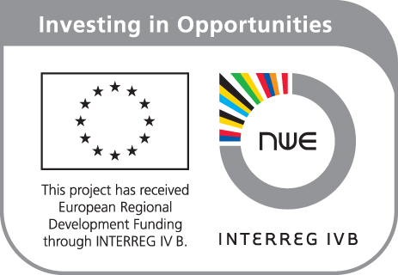

Dear Mr/Ms,

We are pleased to offer you the invitation to attend the:

BioenNW Final International Conference

Bioenergy Networks and Biomass Potentials - Valorising European Organic Residues
24th September 2015, EUBIA Congress Centre, Rond Point Schuman 6, B1040, Brussels, Belgium

To request your free place*, please fill in the form below and send it back to andrea.salimbeni@eubia.org

Full name
Job title
Company
Address
Email
Telephone

Yours Sincerely,

Joanna Fletcher
BioenNW Project Coordinator

* The event is completely free of charge

